AI ASSISTED CODING
ASSIGNMENT-4.3
Name: M. Meghana
Hallticket No: 2303A52505
Batch: 50

Lab 4: Advanced Prompt Engineering – Zero-shot, One-shot, and Few-shot
Techniques
Lab Objectives
• To explore and apply different levels of prompt examples in AI-assisted code
generation
• To understand how zero-shot, one-shot, and few-shot prompting affect AI
output quality
• To evaluate the impact of context richness and example quantity on AI
performance
• To build awareness of prompt strategy effectiveness for different problem
types
Week2 -
Wednesday
Lab Outcomes (LOs)
After completing this lab, students will be able to:
• Use zero-shot prompting to instruct AI with minimal context
• Use one-shot prompting with a single example to guide AI code generation
• Apply few-shot prompting using multiple examples to improve AI responses
• Compare AI outputs across different prompting strategies
Task 1: Zero-Shot Prompting – Leap Year Check
Scenario
Zero-shot prompting involves giving instructions without providing examples.
Task Description
Use zero-shot prompting to instruct an AI tool to generate a Python function that:
• Accepts a year as input
• Checks whether the given year is a leap year
• Returns an appropriate result
Note: No input-output examples should be provided in the prompt.
Expected Output
• AI-generated leap year checking function
• Correct logical conditions
• Sample input and output
• Screenshot of AI-generated response (if required)
Prompt:
#write a python function to check whether a given year is leap year or not
Code:
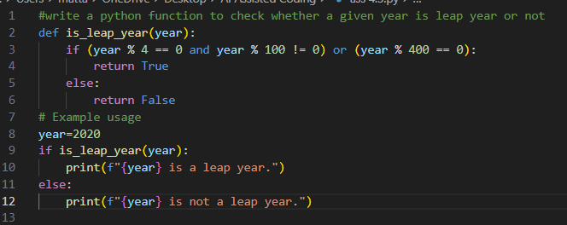
Output:
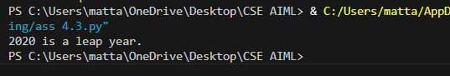
Justification:
Zero-shot prompting was used because only the basic instruction was needed without any examples. The AI correctly applied leap year rules (divisible by 4, not by 100 unless divisible by 400). This shows AI can solve simple logical problems with minimal context.

Task 2: One-Shot Prompting – Centimeters to Inches Conversion
Scenario
One-shot prompting guides AI using a single example.
Task Description
Use one-shot prompting by providing one input-output example to generate a Python
function that:
• Converts centimeters to inches
• Uses the correct mathematical formula
Example provided in prompt:
Input: 10 cm → Output: 3.94 inches
Expected Output
• Python function with correct conversion logic
• Accurate calculation
• Sample test cases and outputs
Prompt:
#write a python function for centimeters to inches conversion , example if input is 10 cm then output should be 3.94 inches
Code:
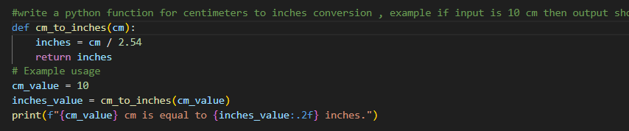
Output:
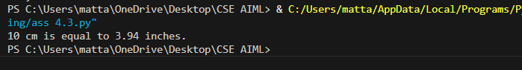
Justification:
One-shot prompting included a single example (10 cm → 3.94 inches), which guided the AI to use the correct conversion formula. The example helped improve accuracy and ensured the output matched the expected format.

Task 3: Few-Shot Prompting – Name Formatting
Scenario
Few-shot prompting improves accuracy by providing multiple examples.
Task Description
Use few-shot prompting with 2–3 examples to generate a Python function that:
• Accepts a full name as input
• Formats it as “Last, First”
Example formats:
• "John Smith" → "Smith, John"
• "Anita Rao" → "Rao, Anita"
Expected Output
• Well-structured Python function
• Output strictly following example patterns
• Correct handling of names
• Sample inputs and outputs
Prompt:
#write a python function to separate last name and first name when full name is given, example if input is "John Smith" output is "Smith,John", if input is "Anita rao" output is "Rao,Anita"

Code:
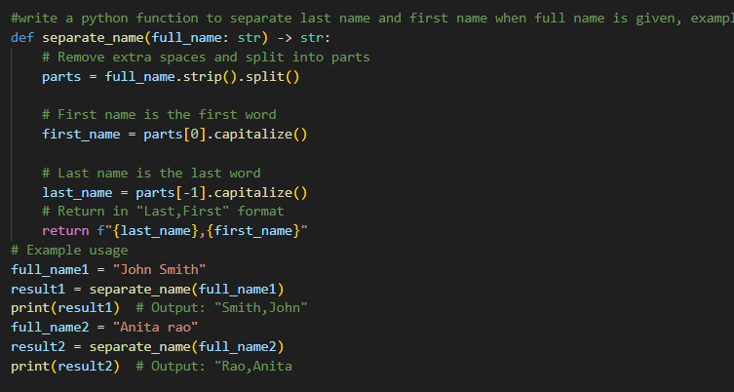
Output:
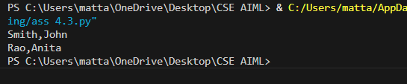
Justification:
Few-shot prompting was effective because multiple examples clearly showed the required “Last, First” pattern. The AI followed the example structure accurately and produced a properly formatted name output.

Task 4: Comparative Analysis – Zero-Shot vs Few-Shot
Scenario
Different prompt strategies may produce different code quality.
Task Description
• Use zero-shot prompting to generate a function that counts vowels in a string
• Use few-shot prompting for the same problem
• Compare both outputs based on:
o Accuracy
o Readability
o Logical clarity
Expected Output
• Two vowel-counting functions
• Comparison table or short reflection paragraph
• Conclusion on prompt effectiveness
Prompt:
Zero-shot:
#Write a Python function that counts the number of vowels in a string. The function should return the total vowel count.
Few-shot:
#generate a python function to count vowels in a given string, example if input is "Hello World" output should be 3, if input is "Python Programming" output should be 4
Code:
Zero-shot:
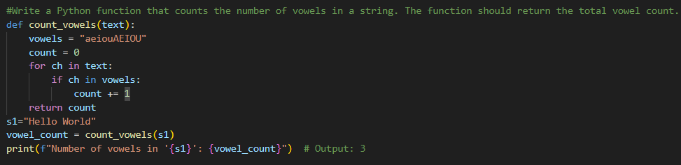
Few-shot:
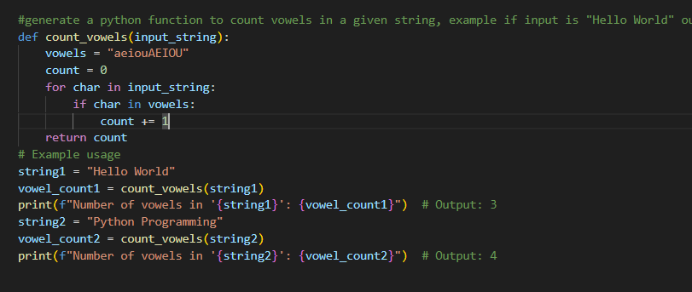
Output:
Zero-shot:
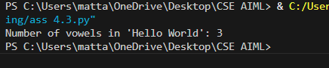
Few-shot:
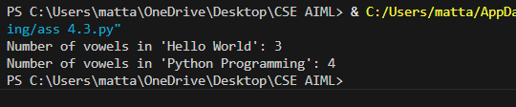
Comparison Table
Criteria | Zero-Shot Output Code | Few-Shot Output Code
Prompt Type | Direct instruction without examples | Instruction with examples provided
Accuracy | Correct vowel count for input string | Correct vowel count for multiple example strings
Readability | Simple and clear for beginners | Also clear, includes more test cases
Logical Clarity | Step-by-step loop approach | Same logic but guided by examples
Coverage | Only one sample test ("Hello World") | Two sample tests ("Hello World", "Python Programming")
Code Quality | Basic implementation | Slightly better demonstration due to examples

Justification:
Both prompts generated correct vowel-counting functions, but the few-shot prompt provided examples that led to better coverage and clearer testing. This demonstrates that additional context improves response quality and completeness.

Task 5: Few-Shot Prompting – File Handling
Scenario
File processing requires clear logical understanding.
Task Description
Use few-shot prompting to generate a Python function that:
• Reads a .txt file
• Counts the number of lines in the file
• Returns the line count
Expected Output
• Working Python file-processing function
• Correct line count
• Sample .txt input and output
• AI-assisted logic explanation
Prompt:
#Generate a Python function that reads a .txt file, counts the number of lines, and returns the total line count.exmaple if input file has 3 lines output should be 3 if input file has 10 lines output should be 10

Code:
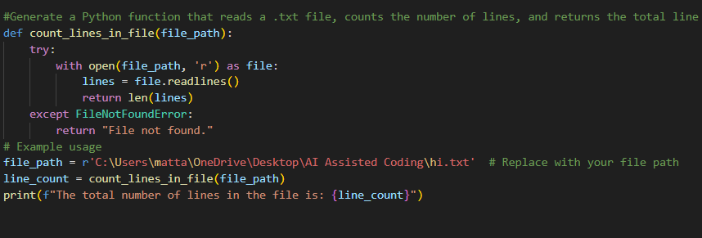
Output:
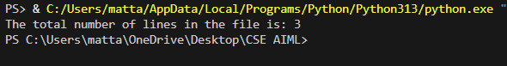
Justification:
Few-shot prompting helped the AI understand the expected line-counting output using file examples. The function correctly reads a text file, counts lines, and returns the total, showing improved clarity for real-world file handling tasks.

